Instructions

Use pages 4-5 of this document to provide the details for a new symbol to add to the EMUFI inventory. Highlighted text should be replaced with the symbol details. Only these pages need be returned. Pages 2-3 provide an example from an existing entry. Form fields are described in the following. Optional fields may be filled in later by EMUFI reviewers who will coordinate with you.

Ge’ez Name: A common or colloquial name in Ge’ez. [Optional]

English Name: A common or colloquial name in English. [Required]

Symbol Name: A “Unicode style” symbol name in uppercase in keeping with Unicode and ISO 10646 conventions. Optional for submission.

Description: A short description of the symbol. [Required]

Recommended Encoding: If known, indicate that the symbol should be treated as one of: “Alternative Glyph”, “Code point”, “Ligature”, “Kerning Pair”, or “Graphical”. The “Usage” notes should attempt to justify this recommendation. [Optional]

Contextual Sample: A text sample of the symbol in use. It is recommended that the sample correspond to the required “Image Sample”. The contextual sample is intended to help validate the EMUFI reference font and thus requires the symbol to be added to the font. You may add the symbol to the font if you are comfortable with font editor software. Otherwise adding the sample text without the symbol is helpful and an EMUFI team member will work with you to add the symbol to the font and to update the sample text. [Optional]. The “EMUFI Dev” font may be found here:

https://github.com/geezorg/emufi/raw/master/fonts/EMUFI-Abyssinica/EMUFI-Dev-COLR.ttf

Usage: A longer description of how the symbol is used in manuscripts. Indicate if the glyph is in “Modern” (current) or “Historic” use. [Required]

Glyph Notes: Notes on the shape of the glyph that would be relevant to font designers. Notes on shape variation, particularly any variation in the presence of other symbols. The notes may indicate that there are no observed variations. [Required]

Validation Notes: Notes on how the symbol has been validated and by who. Add any additional notes on context of the submitted sample. The expert validator’s name may be removed from the inventory document so as not to influence the views of other experts during the review phase. [Required]

References: Example occurences of the symbol in manuscripts. A shorthand title may be used to refer to the manuscript citation given in the “Bibliography” section. [Required]

Bibliography: The complete citation for manuscripts cited in the “References” section. These works will be aggregated with other references in the full EMUFI inventory document. [Required]

Image Sample: A scan clearly depicting the sample from a cited reference. The scan may appear on a separate page. A clear photo taken by a mobile phone is also acceptable. [Required]
Ge’ez : ደረት፡ድፋት፡


English: Deret-Difat

Symbol Name: | ETHIOPIC TONAL MARK DERET DIFAT
Description: | Deret-Difat is a tonal sequence composed from the two Qirts elements “Deret” (᎑) and “Difat” (᎔). Respectively, ETHIOPIC TONAL MARK DERET (U+1391) and ETHIOPIC TONAL MARK DIFAT (U+1394).
Recommended Encoding: | Code point.
Contextual Sample: | አዳም፡ሕንፄሃ፡ሐመልማለ፡ወርቅ፡ገበዋቲሃ፡  Tsome Digua p. 136
Usage: | Modern.  Deret-Difat is vocalized as Deret followed by Difat.
Glyph Notes: | The upper Difat is raised above the top of the lower Deret a distance of 30% of the Deret’s height. At smaller point sizes the two symbols should not appear to come in contact with one another.
References: | Digua p. 76, 94, 290  Tsome Digua p. 116, 136, 184  Me’eraf p. 66, 71, 73, 99, 107, 112, 122  Zimarie Wemewasit p. 34, 68
Validation  Notes: | Reviewed by Liqa Mezemran Moges Seyoum.
Image Sample: | 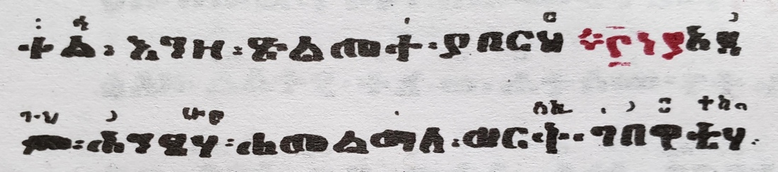  Tsome Digua p. 136

Bibliography

Gebre-Amanuel, Like Kahnat Berhanu, ed., ዝማሬ ወመዋሥዕት Zimarie WeMewas'et, Berhanina Selam Matemiya Dirjit, Addis Ababa, 1986EC/1993
Gebre-Amanuel, Like Kahnat Berhanu, ed., መጽሐፈ ድጓ - ዘቅዱስ ያሬድ Metsehaf Degua - ZeKidus Yared, Nigid Matemiya Dirjit, Addis Ababa, 1988EC/1995
Tinsaie Mastemiya Dirjit, ምዕራፍ ዘቅዱስ ያሬድ Me’eraf ZeKidus Yareid, Comercial Publishing Enterprise, Addis Ababa, 1987EC
Tinsaie Zegubaie Matemiya Biet Tateme, ጾመ ድጓ ዘቅዱስ ያሬድ Tsome Digua – ZeKidus Yared, Tinsaie Zegubaie Matemiya Biet Tateme, Year Unknown (1980s EC)

Ge’ez : ግዕዝ፡ስም፡
x

English: English-Name

Symbol Name: | ETHIOPIC XXX (UPPERCASE NAME)
Description: | Short description of XXX
Recommended Encoding: | [Alternative Glyph | Code point | Ligature | Kerning Pair | Graphical].
Contextual Sample: | text sample  Sample source
Usage: | [Modern | Historic].  A longer description of how the symbol is used in manuscripts.
Glyph Notes: | Notes on the shape of the glyph relevant to font designers. Notes on shape variation, particularly in the presence of other symbols. The notes may indicate that there are no observed variations.
References: | Title X p. 12, 17, 19-  Title Y p. 2, 7, 8, 9, 21, 24, 30, 34
Validation  Notes: | Notes on how the symbol has been validated and by who. Add any additional notes on context of the submitted sample.
Image Sample: | A scan clearly depicting the sample from a cited reference, the scan may be identical to the Contextual Sample. The scan may appear on a separate page. A clear photo taken by a mobile phone is also acceptable.

Bibliography
Author Last Name, First Name, Title-Ethiopic Title-Transliterated, Publisher, City, Year-Ethiopic/Year-Gregorian

